**Mohan Ram.J**

**REG.NO:192224175**

**CSA1473-COMPILER DESIGN**

1. Write a LEX program to identify the capital words from the given input.

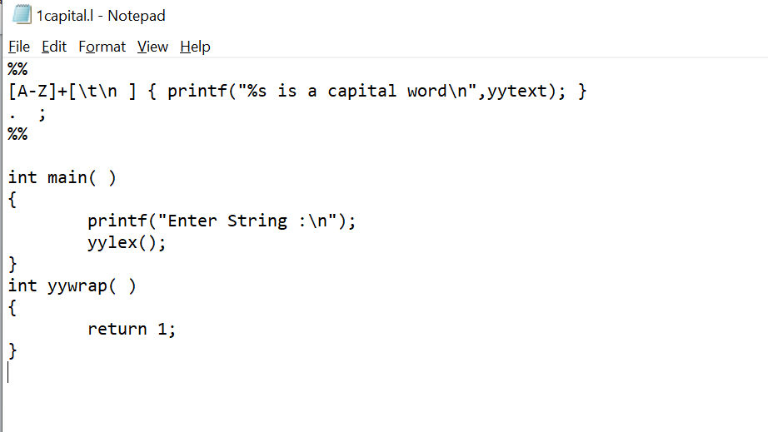

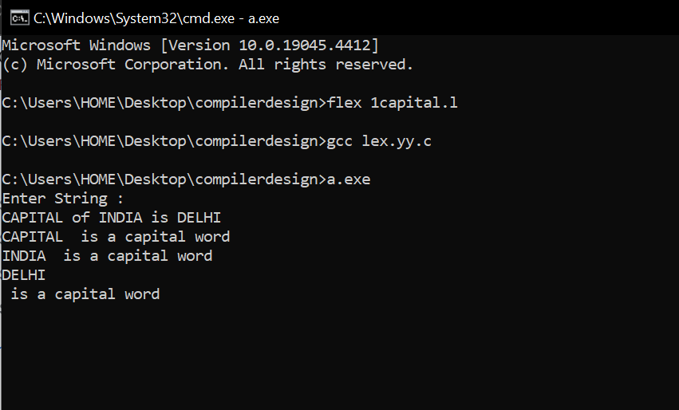

1. Write a LEX program to check whether the given input is digit or not.

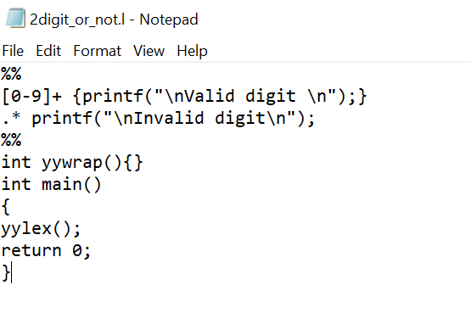

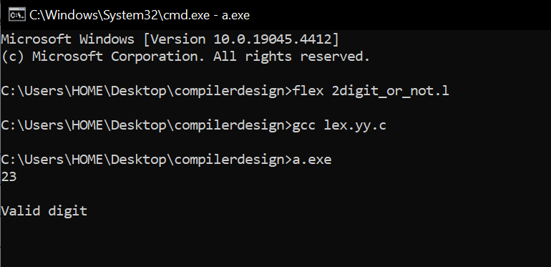

1. Implement a LEX program to check whether the mobile number is valid or not.

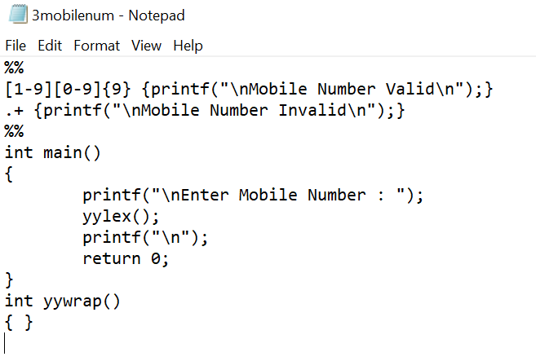

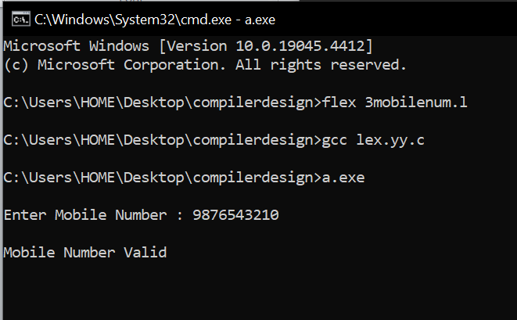

1. Write an algorithm to help the student to count the number of vowels and consonants in the given sentence

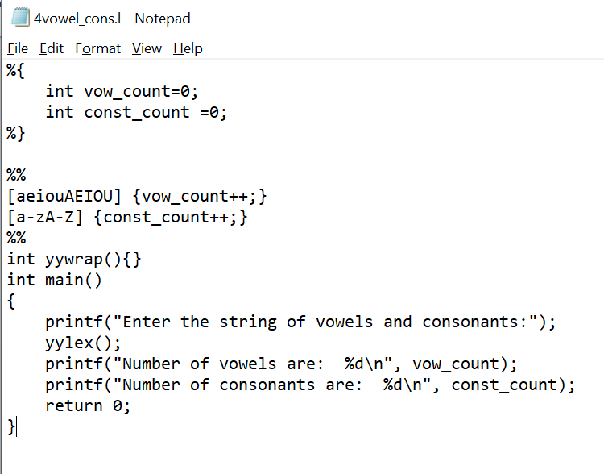

1. Write a LEX program to separate keywords and identifiers.

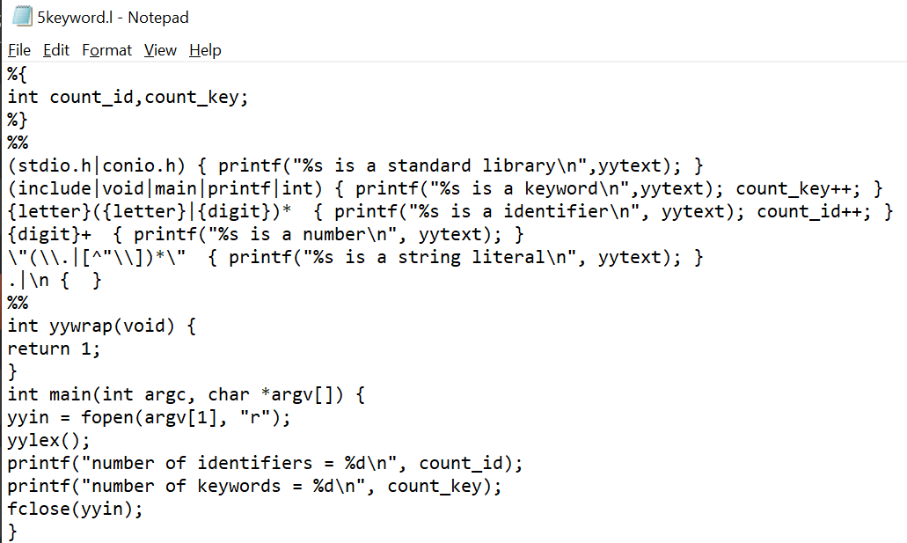

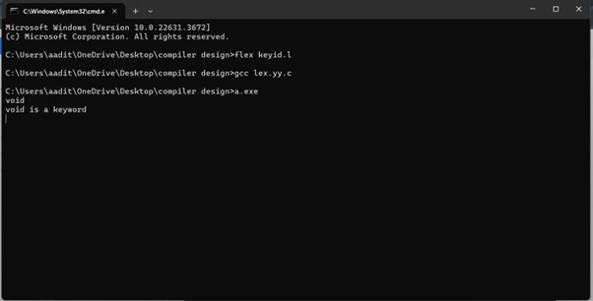

1. Write a LEX program to identify and count positive and negative numbers.

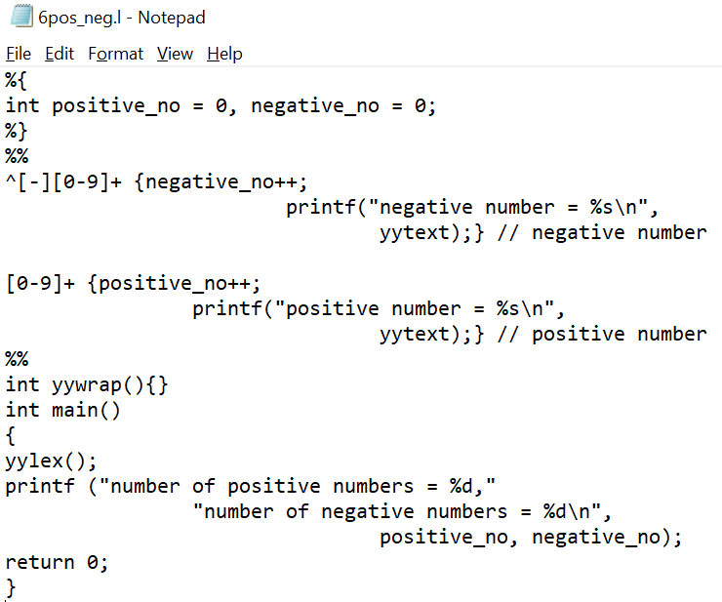

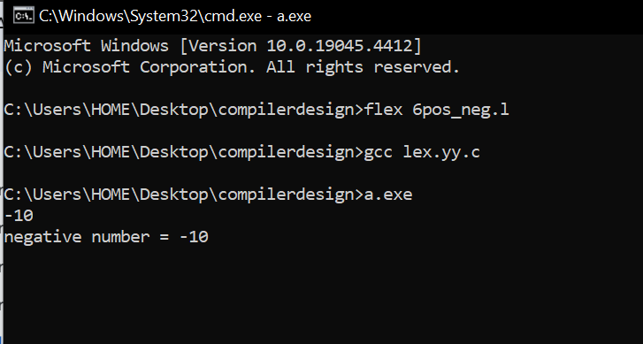

1. Write a LEX program to recognize numbers and words in a statement.

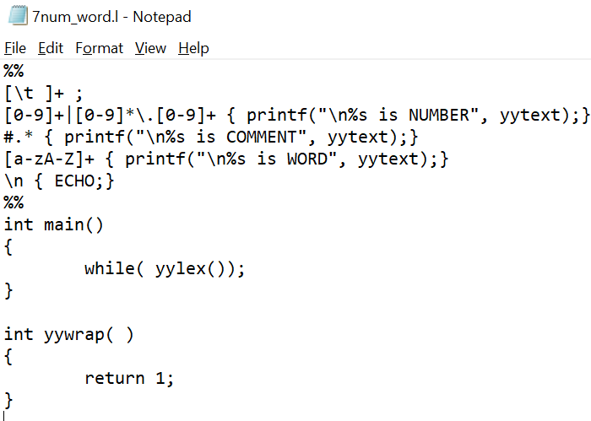

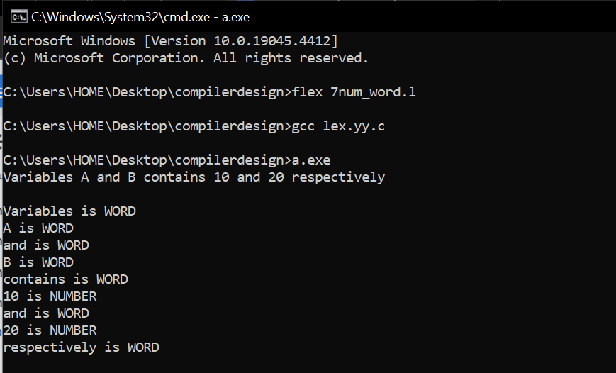

1. Write a LEX program to accept string starting with vowel.

